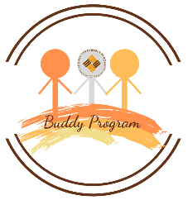
Buddy Program
Fall semester 2019
The Buddy Programme aims to match each incoming student with a local student of the UER, who can give you a hand with the doubts you might have and will be your mate. Furthermore, we organize some fun activities so that you can spend some quality time with your new buddy.
Please fill in the following form so that we can offer you a more suitable experience at UER.
Name and Surname:

In which kind of extracurricular activities are you interested?
- Cultural (trips, visits to monuments, museums, etc.)
- Social (cinema meetings, cooking competitions, etc.)
- Sporting (football games, canoe, etc.)
- Language (language exchange)
- Professional training (Workshops on Linked-in, interview, CV, etc.)
- Christian ( events in the Vatican, evangelization mission trips, etc)
- None

Why did you want to come to Rome?
______________________________________________________________________________________
______________________________________________________________________________________

Do you have any suggestion of activity that you would like to do?
______________________________________________________________________________________
______________________________________________________________________________________

Would you like to be informed of the activities and contacted by your Buddy by Whatsapp?
- Yes. If yes, please write your telephone number (with prefix) +______________________
- No

